4. Given a 0-indexed integer array nums of length n and an integer k, return the number of
pairs (i, j) where 0 &lt;= i &lt; j &lt; n, such that nums[i] == nums[j] and (i * j) is divisible by k.
Example 1:
Input: nums = [3,1,2,2,2,1,3], k = 2
Output: 4
Explanation:
There are 4 pairs that meet all the requirements:
- nums[0] == nums[6], and 0 * 6 == 0, which is divisible by 2.
- nums[2] == nums[3], and 2 * 3 == 6, which is divisible by 2.
- nums[2] == nums[4], and 2 * 4 == 8, which is divisible by 2.
- nums[3] == nums[4], and 3 * 4 == 12, which is divisible by 2.
Example 2:
Input: nums = [1,2,3,4], k = 1
Output: 0
Explanation: Since no value in nums is repeated, there are no pairs (i,j) that meet all the
requirements.
INPUT :
def countPairs(nums, k):
count = 0
n = len(nums)

for i in range(n):
for j in range(i + 1, n):
if nums[i] == nums[j] and (i * j) % k == 0:
count += 1

return count

n = int(input("Enter number of elements: "))

nums = []
print("Enter the elements:")
for i in range(n):
nums.append(int(input()))

k = int(input("Enter k: "))

print("Output:", countPairs(nums, k))
OUTPUT:
EXAMPLE 1
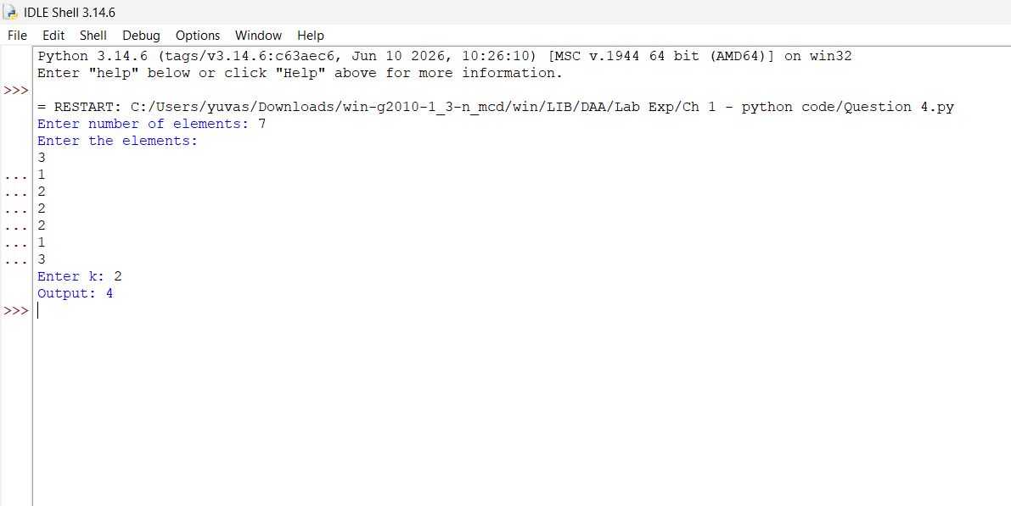
EXAMPLE 2
